Compilation d’articles sur les explosions et incendies
provoqués par les smart meters
(en anglais)
Compilation effectuée le 26 octobre 2015
http://www.globalresearch.ca/thousands-of-smart-meter-fires-new-whistleblower-and-court-evidence/5462760

Thousands of Smart Meter Fires: New Whistleblower and Court Evidence
By Brian Thiesen
Global Research, July 16, 2015
Take Back Your Power 14 July 2015

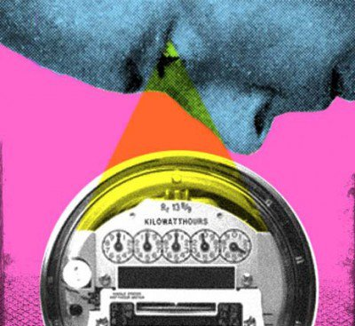
The situation with smart meter fires is worse than we thought — and now we know why. This new investigative video tells all.
In studying, doing presentations and making videos on ‘smart’ meters for nearly 5 years now, personally I had my doubts I would learn anything new when I first connected with a utility worker whistleblower through Take Back Your Power.
I was completely wrong and they are right. It is worse than I thought — than we all thought. A major and critical error has been brought forth.
Why are meters exploding off houses by the 100’s at a time? Why are fires happening no matter where smart/digital meters are being installed?
This new video (above) explains in simple terms these new revelations from the insiders, as well as new court documentation and other insights.
The whistleblowers (wishing to remain anonymous) who contacted us have serviced and repaired over 200,000 meters in the field. They have been warning their supervisors about ‘smart’ meter problems for nearly a decade now. They have had enough of the lies and want you to know what they know.
On top of the explosive new details, the meters have at least four major sources of arcing. That’s right — FOUR.
Arcing in ‘smart’ meters causes extreme heat, which causes fires. As we now see, it is beyond any shadow of a doubt that meter manufacturers know, utilities know, and regulators know. They have known the whole time, but they didn’t want to tell you.
In this investigation the focus on two of the worst offenders, BC Hydro and PG&E. However, as this is a systemic problem regardless of meter type, we feature fire incidents from Texas, Ontario, Saskatchewan, Pennsylvania, Illinois and more.
Of note, for those that have been following the BC Freedom process to keep your safe analog meter, you can see how BC Hydro, the BCUC, and government (including Measurement Canada) are now all implicated in collusion to attempt to remove your choice to keep your analog meter. If you have held out this long, regardless of where you are, you are going to be glad you did — and you are going to have all the ammo you need to break the chain of deceit that permeates these groups.
The whistleblowers who contacted us have serviced and repaired over 200,000 meters in the field.
On top of our whistleblower information, we have industry documents being revealed for the first time. Utilities do not want this info to get out. Why are metersexploding off houses by the 100’s at a time? Why are fires happening no matter where smart/digital meters are being installed? Sensus, Itron, Landis + Gyr, etc: why is it that all these meter makers are having issues everywhere they are being installed?
We know you have questions. Take them into this video. What you learn is going to blow you away just as it did us when we first learned about what’s really going on.
You are going to see just how much money is involved, corruption at the highest levels, and why you and your safety are in the way of profits — which is why you have not been be told the truth… until now. The bottom line: it is now up to us to hold these people accountable and liable for their negligence and harm they are causing to all of us.
People like Larry Nikkel, James Humphrey, Michelle Sherman, and very likely this family of five — have all died from ‘smart’ meter fires.
Utilities and pocket-lining officials see the harm to your property, biological health and basic rights merely ascollateral damage on their way to profits from data. According to the National Association of Regulatory Utility Commissioners (NARUC), this ‘smart’ meter data will be “a lot more” valuable than the electricity itself. In case you were wondering, the electricity market globally is $2.2 Trillion USD.
The facts behind ‘smart’ fires are now here. Electricity is cut and dry. It is has basic laws and functions that have been set in stone for over a century.
In their quest for profit, all of our privacy rights are being violated for their sake of their profit. Homes are burning down. And people like Larry Nikkel, James Humphrey, Michelle Sherman, and very likely this family of five — have all died from ‘smart’ meter fires. While those in charge continue to lie.
We cannot afford to tolerate this any longer.
------------
https://takebackyourpower.net/1000s-of-smart-meter-fires-new-whistleblower-court-evidence-video/

1000’s of smart meter fires: New whistleblower & court evidence (video)
July 14, 2015
by Brian Thiesen
explosions, fires, smart meters, video, whistleblower
15 Comments
*** 1 Oct 2015: UPDATED VIDEO TO BE POSTED SOON ***
The situation with smart meter fires is worse than we thought — and now we know why. This new investigative video tells all.
In studying, doing presentations and making videos on ‘smart’ meters for nearly 5 years now, personally I had my doubts I would learn anything new when I first connected with a utility worker whistleblower through Take Back Your Power.
I was completely wrong and they are right. It is worse than I thought — than we all thought. A major and critical error has been brought forth.
Why are meters exploding off houses by the 100’s at a time? Why are fires happening no matter where smart/digital meters are being installed?
This new video (above) explains in simple terms these new revelations from the insiders, as well as new court documentation and other insights.
The whistleblowers (wishing to remain anonymous) who contacted us have serviced and repaired over 200,000 meters in the field. They have been warning their supervisors about ‘smart’ meter problems for nearly a decade now. They have had enough of the lies and want you to know what they know.
On top of the explosive new details, the meters have at least four major sources of arcing. That’s right — FOUR.
Arcing in ‘smart’ meters causes extreme heat, which causes fires. As we now see, it is beyond any shadow of a doubt that meter manufacturers know, utilities know, and regulators know. They have known the whole time, but they didn’t want to tell you.
In this investigation the focus on two of the worst offenders, BC Hydro and PG&E. However, as this is a systemic problem regardless of meter type, we feature fire incidents from Texas, Ontario, Saskatchewan, Pennsylvania, Illinois and more.
Of note, for those that have been following the BC Freedom process to keep your safe analog meter, you can see how BC Hydro, the BCUC, and government (including Measurement Canada) are now all implicated in collusion to attempt to remove your choice to keep your analog meter. If you have held out this long, regardless of where you are, you are going to be glad you did — and you are going to have all the ammo you need to break the chain of deceit that permeates these groups.
The whistleblowers who contacted us have serviced and repaired over 200,000 meters in the field.
On top of our whistleblower information, we have industry documents being revealed for the first time. Utilities do not want this info to get out. Why are meters exploding off houses by the 100’s at a time? Why are fires happening no matter where smart/digital meters are being installed? Sensus, Itron, Landis + Gyr, etc: why is it that all these meter makers are having issues everywhere they are being installed?
We know you have questions. Take them into this video. What you learn is going to blow you away just as it did us when we first learned about what’s really going on.
You are going to see just how much money is involved, corruption at the highest levels, and why you and your safety are in the way of profits — which is why you have not been be told the truth… until now. The bottom line: it is now up to us to hold these people accountable and liable for their negligence and harm they are causing to all of us.
People like Larry Nikkel, James Humphrey, Michelle Sherman, and very likely this family of five have all died from ‘smart’ meter fires.
Utilities and pocket-lining officials see the harm to your property, biological health and basic rights merely as collateral damage on their way to profits from data. According to the National Association of Regulatory Utility Commissioners (NARUC), this ‘smart’ meter data will be “a lot more” valuable than the electricity itself. In case you were wondering, the electricity market globally is $2.2 Trillion USD.
The facts behind ‘smart’ fires are now here. Electricity is cut and dry. It is has basic laws and functions that have been set in stone for over a century.
In their quest for profit, all of our privacy rights are being violated for their sake of their profit. Homes are burning down. And people like Larry Nikkel, James Humphrey, Michelle Sherman, and very likely this family of five — have all died from ‘smart’ meter fires. While those in charge continue to lie.
We cannot afford to tolerate this any longer.

SMART METER FIRES: Fatalities & Liability
• Another 100 smart meters simultaneously explode (Capitola, CA – May 2015)
• Hundreds of smart meters simultaneously explode (Stockton, CA – April 2015)
• Smart meter fire kills 74-year old man in Dallas, Texas (February 2015)
• Man dies in “smart” meter fire (Vacaville, CA – July 2013)
• Fatal fire, smart meter suspected:“Be very aware, very vigilant” says Fire Chief (Reno, NV – Sept 2014)
• Couple escapes house fire, dogs killed: smart meter blamed (Detroit, MI – October 2014)
• SaskPower to replace 105,000 faulty “smart” meters (Saskatchewan, CAN – July 2014)
• SaskPower CEO resigns following investigation into smart meter “catastrophe” (October 2014)
• PGE to replace 70,000 faulty “smart” meters (Portland, OR – July 2014)
• Lakeland Electric to replace over 10,000 faulty “smart” meters (Lakeland, FL – August 2014)
• Are tens of thousands of defective “smart” meters being stealthily replaced in Arizona? (Sept 2014)
• PECO replaces 186,000 faulty “smart” meters (Philadelphia, PA – October 2012)
• News & articles on fires – Take Back Your Power
• Archive of hundreds of documented “smart” meter fires – EMF Safety Network

About the Author
Brian Thiesen is a British Columbia-based researcher who studies finance, economics, geo-politics smart meters/grid among other subjects. He has spent the last 5 years studying, doing presentations and videos on smart meters, and is active in preventing smart meter installs in BC. His website is BC-Freedom.com.

------------------

https://takebackyourpower.net/hundreds-of-smart-meters-simultaneously-explode/

Hundreds of smart meters simultaneously explode
April 01, 2015
by Josh del Sol
california, corruption, explosions, fires, smart grid, smart meters, Stockton
16 Comments
The utilities lied when they said “smart” or AMI meters would make the electricity grid “resilient” and “self-healing.”
Nothing could be further from the truth, and this latest episode is more proof of the failure of “smart” meter programs everywhere.
On Monday, hundreds of “smart” meters simultaneously exploded in Stockton, California, when a truck ran into a utility pole. Watch the video:

Source: http://sacramento.cbslocal.com/2015/03/30/stockton-smart-meters-explode-after-truck-causes-power-surge/
CBS News reported that “neighbors in the South Stockton area described it as a large pop, a bomb going off, and strong enough to shake a house.”
The catastrophic failure of these PG&E “smart” meters — which are not approved by Underwriters Laboratories (UL) — not only damaged meter bases and other homeowner property, but left those 5,800 customers without power.
That’s right — whenever these plastic, unproven meters fail, they shut your power off, as shown in this Cambridge University research paper.

Source: https://www.youtube.com/watch?v=gOqucXzwKkA
Last July, the province of Saskatchewan ordered the removal of all 105,000 “smart” meters, following a rash of fires. Portland OR, Lakeland FL, Arizona and Ontario followed suit with mass removals.
Quebec firefighters are up-in-arms that Hydro-Quebec agents have actually been unlawfully taking “smart” meters from fire scenes prior to investigation.
Analog meters are not susceptible to fires. The risk of fires is a “smart” new feature for all customers, brought to you by your PR-spinning utility. Back in 2011, after a similar power surge ignited 80 “smart” meters in Palo Alto, California, a spokesperson for The Utility Reform Network (TURN) stated:
“In the collective memory of TURN, we have not seen similar incidents with analog meters.”
The total number of separate incidents of fires and explosions caused by “smart” meters is now very likely to exceed a thousand or more, although the true number is not known due do widespread coverups and denials by utilities.
In addition to the ongoing stream of incendiary events, so-named “smart” meter programs:
- are enshrouded in fiscal negligence;
- are not shown to save energy;
- are linked with systemic billing inaccuracy and widespread increase of bills;
- facilitate “time-of-use” billing and future artificial austerity measures;
- facilitate monitoring of your activities and external control of your home;
- open the door to unprecedented hacking vulnerabilities; and
- emit pulsed microwave radiation typically thousands of times stronger than a cell phone, leaving many unsuspecting homeowners feeling ill.
It is difficult to imagine a more blatant failure, or a more harmful deployment of unproven technology.

If this is true, how can utilities be getting away with it?
The “smart” meter deployments in your area are actually part of a corporate-government collusion to deploy a mass in-home data-capturing (read surveillance) and control grid — the “internet of things”.
Here are three main takeaway points:
- As new appliances are being designed to collect detailed activity and report in real-time through the “smart” meter, it’s estimated that the combined data they collect on all of us will be worth more than the entire electricity industry.
- Industry wants to pocket trillions in this shift to an information economy, with you as the resource being packaged and sold — without your consent, of course.
- With industry selling the wireless convenience and glorious modernization of it all, these deployments are being pushed through under the guise of climate action. Go Green!
If this sounds like a stretch, examine the evidence for yourself.
The “smart” meter agenda, once fully spawned, would facilitate an unprecedented transfer of money, control, information and security from people to the corporate-government complex (CGC).
The reason why there has been so much industry and government propaganda around the”smart” meter issue is because the scope of this pillaging is, again, unprecedented. This is also why those attempting to change to a sane course of action from within the CGC have not yet been successful.
But as awareness spreads, scandals increase (like this one in California), and people take inspired action, I see that the “smart” meter agenda will fail and the pseudo-powers behind it will fall.

So, what are we going to do about it?
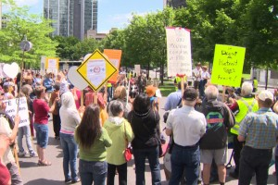By protecting our individual rights, we are protecting all of life.
Advocate groups worldwide are encouraged to demand immediate halt and reversal of all “smart” meter deployments, whether they be for electricity, water, or gas. It does not matter how much money was invested before people became aware of the facts about harm being perpetrated. We’re aware now.
An “opt-out” program — whether paid or free — must categorically be rejected because asking for an “opt-out” is voting that you generally approve the installation of a surveillance grid, the harming of everyone else, and the practice of corporate extortion.
Individually, here are three things you can do right now.
- Once you become aware of the facts, remove your consent in writing (see example). This is simple, yet fundamental: your utility has made you an offer. You have the right to (and need to, contractually) either refuse or conditionally accept in writing, any written piece of paper they send your way. Note: everything they send you — indeed every communication they have with you — is essentially a contract offer, which in commerce is deemed accepted if it’s not rebutted.
- Spread the word. Share the facts and solutions, starting with those you know: family and friends, via email and social media. Get together and form a local action group. Subscribe your email via www.takebackyourpower.net and stay tuned to developments.
- Hold the individuals involved liable for causing or allowing this widespread crime. While this is not legal advice, an effective strategy appears to be treating their offer of a “smart” meter purely as a commercial transaction. You can use the same commercial codes and contract laws on which the for-profit corporate system is based, against its agents.Also, here are couple areas of law which are applicable and being used by some groups:
ultrahazardous activity:
“An activity or process that presents an unavoidable risk of serious harm to the other people or others’ property, for which the actor may be held strictly liable for the harm, even if the actor has exercised reasonable care to prevent that harm.” –https://www.law.cornell.edu/wex/ultrahazardous_activity
strict liability:
1.Civil (tort): Liability incurred for causing damage to life, limb, or property by a hazardous activity or a defective product, without having to prove that the defendant was negligent or directly at fault. It arises not from any wrongdoing but from the fact of the activity or product being inherently hazardous or defective.
2.Criminal: Liability imposed by a statute without the necessity of proving criminal intent (see mens rea), and intended to absolutely forbid certain acts such as preparation and sale of adulterated or contaminated food. –http://www.businessdictionary.com/definition/strict-liability.html
We will continue to release news and developments on our website, www.takebackyourpower.net, where you can watch our award-winning feature film which covers the shocking true story about “smart” meters.

About the Author
Josh del Sol is the director and producer of Take Back Your Power: Investigating the “Smart” Grid, which has won the AwareGuide Transformational Film of the Year, the Indie Fest Annual Humanitarian Award, and Leo Award for Best Feature Documentary (British Columbia).

About the Author
Josh del Sol is the director and producer of Take Back Your Power, a revelatory documentary feature film uncovering the worldwide ‘smart’ metering and grid agenda. Watch the film and subscribe to updates at www.takebackyourpower.net, and follow him via twitter @TBYPfilm.
---------------------------------------

https://takebackyourpower.net/smart-meter-fire-kills-74-year-old-man-dallas-tx/

Smart meter fire kills 74-year old man in Dallas, Texas
February 03, 2015
by TBYP Communications
corruption, Dallax, damage, fatality, fires, oncor, smart meters
23 Comments
607
SHARES
FacebookTwitterSubscribe

article text by Monica Hernandez, ABC/WFAA | see original article
A fatal “smart” meter fire has claimed the life of James Humphrey, Jr., 74, in Dallas, Texas. And in all likelihood, just like with HUNDREDS of other fires, the utility cartel will attempt to deflect blame. -TBYP
DALLAS — A family believes an Oncor electrical meter sparked a fire that killed a man in South Dallas Tuesday night. Now, investigators are working with Oncor to see whether that’s the cause.
The fire happened in the 4000 block of Spring Avenue around 10:30 [Monday] night. The next morning, family members still trying to process their loss looked over the charred remains of James Humphrey, Jr.’s home.
Relatives who live next door tried to rescue him, but the flames pouring out of his bedroom window were so heavy, no one could get in. Firefighters found him dead on his bedroom floor.

James Humphrey, Jr., 74, was killed on Monday night from a fire which appears to be caused by a so-named “smart” utility meter.
“He had lived his life, and he had a good life, but he just didn’t deserve to lose his life like this,” said Alfreda Johnson, Humphrey’s cousin and caregiver.
Johnson, who lives next door, went to check on Humphrey just before the fire broke out — never expecting it would be the last time she’d see him. She says Humphrey’s arthritis probably made it difficult for him to escape, but believes none of this would have happened if Oncor hadn’t installed a new smart meter on the home three weeks ago.
She believes the home’s wiring is too old for the new meter, claiming that’s also the reason a fire broke out at her home next door three years ago.
“When are they going to own up and take responsibility for these old houses? They’re putting these smart meters out here and these old houses cannot carry the weight of those smart meters with the wiring,” said Johnson.

SMART METER FIASCO: Fatalities & Liability
• Man dies in “smart” meter fire (Vacaville, CA – July 2013)
• Fatal fire, smart meter suspected: “Be very aware, very vigilant” says Fire Chief (Reno, NV – Sept 2014)
• Couple escapes house fire, dogs killed: smart meter blamed (Detroit, MI – October 2014)
• SaskPower to replace 105,000 faulty “smart” meters (Saskatchewan, CAN – July 2014)
• SaskPower CEO resigns following investigation into smart meter “catastrophe” (October 2014)
• PGE to replace 70,000 faulty “smart” meters (Portland, OR – July 2014)
• Lakeland Electric to replace over 10,000 faulty “smart” meters (Lakeland, FL – August 2014)
• Are tens of thousands of defective “smart” meters being stealthily replaced in Arizona? (Sept 2014)
• PECO replaces 186,000 faulty “smart” meters (Philadelphia, PA – October 2012)
• News & articles on fires – Take Back Your Power
• Archive of HUNDREDS of documented “smart” meter fires – EMF Safety Network
Firefighters are still investigating the cause, which won’t be released until the Medical Examiner’s Office releases a cause of death.
Damage has been estimated at $7,000 in structural loss and $2,000 in contents.
The Public Utilities Commission says it has not received safety complaints about smart meters before, but smart meter installations were blamed for two house fires in Arlington back in 2010.
The issue wasn’t with the meters themselves, but a fire investigator there says that when the old meters were pulled out, the main electric feeds to the houses were accidentally pulled as well.
In a statement, Oncor said: “Our thoughts are with the family in this difficult time. We are working closely with the Dallas Fire Department to understand the cause of the fire. While we understand the concerns regarding the meter, it is important to note that due to the nature and function of the advanced meters, there has been no prior instance where such a meter has caused a fire in a dwelling. Nevertheless, we look forward to completing a full investigation.”
A spokesman added that the new digital meters don’t use any more electricity than traditional meters.
Oncor will allow customers to opt out of the smart meters, for a price.
According to a company spokesperson, depending on the customer’s individual set up, there is a one-time fee to swap to a “regular” meter, then a monthly opt-out fee.
For residential customers, the one-time swap fee ranges from $169 to $211. For commercial customers, it ranges from $244 to $564. Then, the monthly reoccurring fee ranges from $26.69 to $31.38, and includes a small charge for a smart meter — even though the customer no longer has one.
Anyone interested in opting out can contact Oncor at 1-888-313-6862.
Source article: http://www.wfaa.com/story/news/local/dallas-county/2015/02/03/74-year-old-killed-house-fire-dallas/22786269/
-----------

http://stopsmartmeters.org/2013/06/21/when-smart-meters-kill-the-story-of-larry-nikkel-details-emerge-of-vacaville-ca-smart-meter-fire-death/

When ‘Smart’ Meters Kill: The Story of Larry Nikkel — Details Emerge of Vacaville, CA Smart Meter Fire Death
Posted on June 21, 2013 by onthelevelblog
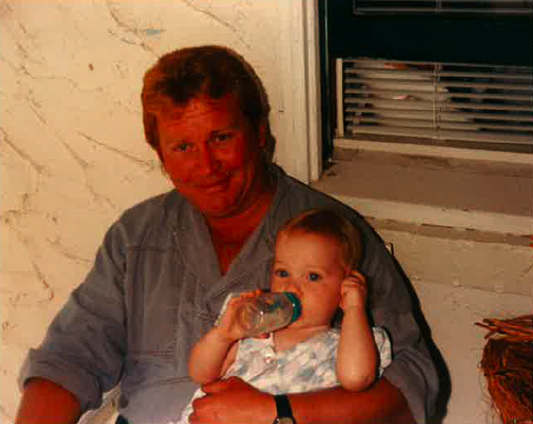
Larry Nikkel
By Joshua Hart, Director StopSmartMeters.Org
Details have come to light of a man killed by a Pacific Gas and Electric (PG&E) Smart Meter that caught fire in Vacaville, CA on July 9th, 2010. Larry Nikkel of 230 Arbor St. died from a suspicious electrical fire that consumed his home the day after Wellington Energy, contractors for PG&E, installed a Landis & Gyr “smart” electric meter. A wrongful death suit lawsuit filed by the family against the utility, subcontractor, and meter manufacturer has now been settled for an undisclosed sum.
The circumstances surrounding Mr. Nikkel’s death add a grave and tragic chapter to the growing human cost of the ‘smart grid.’ The following account is based on interviews with his brother Walter, as well as details obtained by the fire incident report, investigation, and coroner’s report.
Larry Nikkel worked for more than 30 years as the groundskeeper at Solano Community College, and was well liked in Vacaville by those who knew him. He was in a rock band in the Seventies called The Panties who played gigs all over the East Bay. Larry loved his rock music and he loved his 1958 Gretsch guitar (the same kind as Chuck Berry played). The guitar- worth thousands- was given to Larry by a co-worker at the College, underscoring how much he was loved and admired by those who knew him.
Larry was diagnosed with throat cancer in early 2010 and had just finished his chemotherapy treatment at the time of his death. The day before he was killed, he had submitted the paperwork to retire from his job at the Community College. On July 8th, 2010, according to neighbors, Wellington Energy came through and deployed electric smart meters all along the street, including on Larry’s house. Less than 48 hours later, Larry was dead- killed by smoke inhalation and burns from an unexplained electrical fire that consumed his home.
According to his brother Walter, who had spent time with Larry at his house the morning before the fire (and only hours after the smart meter was installed), there were serious electrical problems in the house that day. Larry had tried to boot up his laptop to watch a DVD that evening, but the computer would not function. The cable box did not work either. Walter and Larry both heard a very loud, high pitched “snap” coming from the wall. Later that night, after Walter had returned home, he received a call from Larry, who said that the ‘house was humming.’ He regrets to this day not coming over immediately to investigate what was wrong.
At about 10:30pm on July 9th, a man walking down Arbor St. saw flames coming out of Larry’s house. The man opened the garage door to see if anyone was inside but this caused the fire to “flash” and so he was forced to retreat and call the fire department. By 10:40, fire fighters were on the scene. After battling the fire, crews entered the house and found Larry’s body in the hallway bathroom, under a dresser (which Walt speculates he may have pulled on top of himself to shield against the heat). He had shoved towels under the door, and the water was running in the sink. He was on the floor, having succumbed to smoke inhalation and burns. Larry had placed his beloved guitar in the bathtub, where perhaps he hoped it would survive the flames (it did).
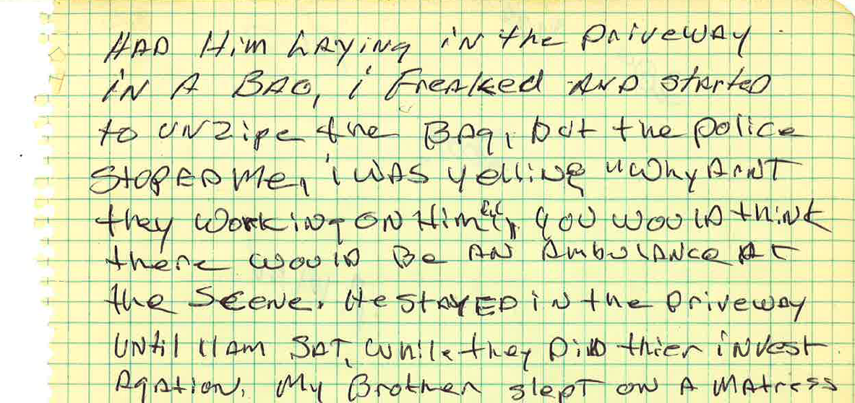
Walter remembers hearing a lot of fire engine sirens that night and wondering whether there was a large grass fire in the area. He received a call from Larry’s neighbor at about the same time, and immediately got a bad feeling. He got in his car and when he arrived at his brother’s house, the house was charred and blackened and Larry’s body was already in a bag. Walter was distraught and started to open the bag but was stopped by the police. “Why aren’t you working on him??” he remembers yelling at the emergency responders.
The official Pathology Report notes that the cause of death was smoke inhalation and thermal injuries (burns):
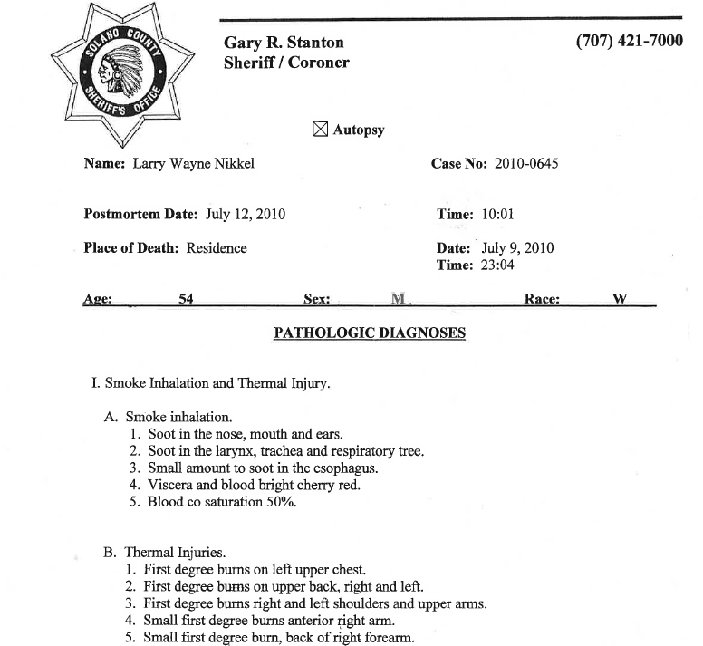

Larry Nikkel was officially pronounced dead at 11:04pm on July 9th, 2010.
The official cause of the fire- according to the Vacaville Fire Department’s Investigation was “undetermined, but was most likely caused by an electrical problem”

Young Larry Nikkel
About a month after the fire, Walter met Ken Burton at the house. Ken was the former bass player in Larry’s band, a friend of the family and also a retired fire fighter. Walter had noticed that his brother’s swamp cooler had fallen to the ground from the window, and was not burned except that the motor was charred, and the belt was melted to the pulley. The two speculated that something had caused the power cord to become so hot that it caught the plywood that fit in the window on fire, and this quickly spread throughout the house.
While they were talking, a fire truck pulled up and Vacaville Fire Dept. Battalion Chief Jansen came up to them. He asked how they were doing, and walked back to the charred breaker box, where two of the breakers were found tripped right after the fire. He asked them if they were aware that the “smart” meter was installed on Larry’s house the day before the fire. It turned out that PG&E had hurriedly removed the meter following the fire.
A month later, Walter was clearing the neighbor’s grape vine out of his tree. That night he started hearing loud buzzing and humming sounds coming from his wall. He immediately called PG&E, who sent a lineman out and discovered that the neutral wire was off the pole. (Walt figures he accidentally pulled the wire off). As a result, 2 TV’s, and a DISH DVR player were fried because of over voltage.
Suddenly, it clicked for Walter. The humming and popping noises. The electrical problems. The “smart” meter having been installed the day before the fire. His brother Larry had died because of PG&E’s smart meter. He did an internet search for “smart meter hazards” and put two and two together, finally grasping what likely killed his brother.
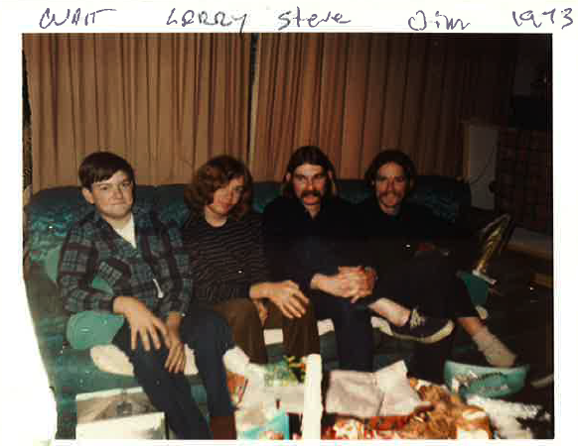According to electrical engineers, the popping, humming, and appliance damage are all telltale signs of an electrical problem caused by arcing, possibly from a meter that was not installed properly. Arcing can lead to fires and explosions. (As we documented in late 2010 in our interview with a whistleblower from Wellington Energy, workers were encouraged to ignore safety hazards and only had 20 hours of training, violating FCC requirements that smart meters be installed by a professional electrician). Larry’s death appears to be a direct result of the kind of violations uncovered by the whistleblower, whose reports were summarily ignored by the CA Public Utilities Commission.
On June 10th, 2012, the Nikkel family filed a lawsuit against Pacific Gas and Electric, Wellington Energy, and Landis & Gyr meter manufacturers, alleging negligence and wrongful death.
The case was settled out of court earlier this year, showing that the utilities and meter manufacturers were alarmed about the potential to lose the case, as well as more terrible publicity related to their meter program. The settlement- though not ideal as it avoids a verdict that might force the utilities to compensate others who have suffered smart meter fires or even recall the meters- has nonetheless provided a sense of closure to the family, who would have had to live through the pain of Larry’s loss once again during a trial.
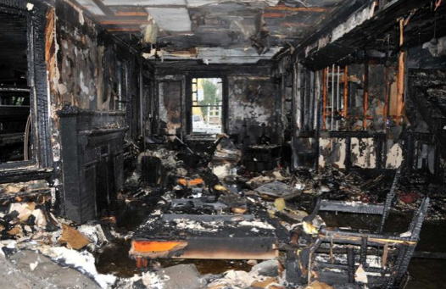
A Stamford CT house fire where 5 people died. The evidence leads to a smart meter as the culprit.
Meanwhile, the number of smart meter fires has continued to grow. Last year, a Stamford CT woman lost five members of her family after a fire likely started by their ‘smart’ meter. Twenty-four hours later, her home was bulldozed, eliminating any evidence that could have been collected showing why the deadly fire started (and preventing future fires) In August 2012, Peco Energy of Pennsylvania was forced to suspend its deployment after at least 26 separate incidents where newly installed smart meters had caught fire or exploded. The EMF Safety Network has tracked many of these fires here, and we have documented a number of these incidents at StopSmartMeters.Org.
A June 15th 2012 presentation by the Ontario Fire Marshal analyzes the numerous smart meter fires being reported in Canada and abroad and states:
“We encountered an unusual amount of fire incidents involving smart meters…prior to any proper investigation the utility company had removed and replaced the meters from the affected areas…New meters may have defects that cause electrical failures (or they may be caused by) careless installation during change over…”
It’s fairly clear by now that there is another major safety problem with smart meters- aside from RF radiation pulses. Hundreds of fires, explosions, and other electrical problems have been documented. Pre-market safety testing simply did not happen in the rush to harvest stimulus funds and corporate profits. The process of third party safety testing might have uncovered these problems before they ended up killing people, but unfortunately UL certification was never sought. In cases of fire, the utility’s strategy has been to blame faulty household wiring, a candle, hot ashes, anything to take the focus away from the smart meter. Homes with old or vulnerable wiring seem to be especially at risk, and surely the utilities know this by now. But they do not warn, and they do not inspect.
If we had responsible utility companies that prioritized health and safety, smart meter deployments could have included a safety check of the socket and wiring. Unfortunately such caution would have required professional technicians to work longer hours- a cost the utility company refused to bear. They can’t seem to have anything get in the way of their guaranteed 11.5% annual returns on shareholder investments (in the case of PG&E). Sadly, for whatever reason most fire departments have failed to investigate smart meter fires as a systemic problem that requires a systemic solution. Meanwhile more homes burn and more people die.
When the Nikkel case came to the attention of Stop Smart Meters! we immediately connected the family with a lawyer and started to try and obtain documents from the Vacaville Fire Dept. Unfortunately, multiple attempts to get a copy of the investigation failed, even when requested by members of Larry’s own family. The attorney for the case- David Kyle- who won his own small claims court case against SCE- said he’s never seen such reluctance to release these kinds of documents. It finally took a subpoena and legal threats to obtain the investigation, something that a bereaved family should not have to go through simply in order to understand why their loved one died.
Unfortunately despite pledges of safety and reform from PG&E and the CPUC following the horrific explosion in San Bruno that killed a dozen people and razed an entire neighborhood, the same decisions are still being made- trading people’s lives for shareholder profit. You needn’t live near a gas pipeline to be at risk. This time it is a device that is being installed on most everyone’s home, in every neighborhood.
While PG&E and other utilities install unsafe devices that are costing some their homes and their lives, the CPUC- led by the industry itself in the form of Mr. Michael Peevey- looks the other way. Such inaction in the face of overwhelming evidence of mortal risk is truly criminal. Let’s make sure that Larry, and others who have lost their lives in the name of the ‘smart grid’ are not forgotten, and that we honor their memory with action and political change.
Larry’s obituary can be found here.

Larry’s guitar pick survived the fire

This entry was posted in California, Cancer, CPUC, Fires, legal issues, PG&E, Smart Grid. Bookmark the permalink.
← Get Wired Event Near London, UK June 23rd
Stop Smart Meters! Investigates: Utilities Lie While People Die →

23 Responses to When ‘Smart’ Meters Kill: The Story of Larry Nikkel — Details Emerge of Vacaville, CA Smart Meter Fire Death
- Pingback: MeterFreedom.org | When ‘Smart’ Meters Kill
- 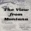elena says:
June 25, 2013 at 8:39 am
Thank you for these updates. I have a question concerning a new so called “ demonstration project” . I live in Montana, Philipsburg. I haven’t any idea as to the extent or even if these Smart meters are being installed here. I know that the town not to long ago had to get water meters(never had them B4), but I have no idea what kind they are.
Recently, NorthWestern Energy has conducted a Smart Grid demo project here in MT (see article below). Do you have any idea what this means? I don’t think they’ve been changing the existing meters , but I know they have with the poles. One such pole down the street starting throwing off sparks so bad that nearby home owners heard the sound B4 realizing what it was. At the same time a major fire broke out about 10-15 miles away destroying several homes and acres. The cause supposedly was a tree falling on the wires connected to the new poles. We have been experiencing several problems with our own home ever since NorthWestern has been doing major pole replacements and additions, testing and planed blackouts.
I know you must be busy, but I hope you can answer my question. I don’t think that people are connecting the dots if they are experiencing the same problems as others which can be attributed to the same cause. A number of us are concerned and would be interested in your answer.
Thank you in advance for your time.
Elena Gagliano
Philipsburg MT
http://www.northwesternenergy.com/display.aspx?Page=Smart_Grid&Item=429
Smart Grid Demonstration Project
Building a more efficient way to move electricity takes careful planning and strategy. Every moment the entire grid must be changed to balance energy supply with the demand for electricity.
NorthWestern Energy has joined with regional partners to develop a smart grid demonstration project using matching stimulus monies from the U.S. Department of Energy (DOE). We’re using innovative technologies to find ways we can enhance the safety, reliability and efficiency of our system.
What is Smart Grid?
Smart Grid is an advanced, telecommunication/electric grid with sensors and smart devices linking all aspects of the current grid, from generator to consumer, and delivering enhanced operational capabilities that:
Provide CONSUMERS with the information and tools necessary to be responsive to electricity grid conditions, including price and reliability, through the use of electric devices and new services.
Ensure EFFICIENT use of the electric grid optimizing current assets while integrating emerging technologies such as renewable and storage devices.
Enhance RELIABILITY by protecting the grid from cyber attacks and other disruptions and also by increasing power quality and promoting early detection and self correcting of the grid.
Our Plan
NorthWestern Energy is planning to prolong the life of our current utility system by utilizing new technology and innovative approaches. This is a two-part plan that occurs on both the utility and customer side of the meter.
On the utility side of the meter, we are piloting conservation voltage reduction (CVR), volt/VAR optimization, and distribution automation. The utility side does not require customer participation – the utility has the ability to adjust the distribution system voltage to conserve energy without affecting customer equipment.
The customer side of the meter requires customer participation. NorthWestern Energy is currently identifying a sample group of customers in Helena and Philipsburg, MT, who will be testing this approach. They will be utilizing Home Area Networks and interval metering, which will give them the tools and know-how to be smarter energy consumers. NorthWestern Energy will monitor and measure customer acceptance and energy use behavioral changes.
NorthWestern’s project is unique in that it will test applications in both small urban and rural settings. Through the project, NorthWestern plans to test techniques that will monitor activities in real time, exchange data about supply and demand and adjust power use to changing load requirements. We will monitor and measure customer acceptance and energy use behavioral changes. This will better inform our decision making about potential future expansions of the Smart Grid.
Reply
  - Alison H says:
September 18, 2014 at 7:59 am
Smart meters are a great concern for many reasons: safety, health, privacy, and escalating costs. I warmly invite you to the world’s first FREE summit on EMF radiation: http://EMFsummit.com
Reply
- Paul H says:
June 25, 2013 at 10:48 am
Time for a recall……..
“Toward a Smart Meter RECALL! Posted on June 24, 2013 by admin
Customers all across the United States have reported being harmed by utility smart meters. In Indiana, a mother of three small children can’t live in their home because a bank of smart meters gave her debilitating health problems. In California hundreds of customers have reported headaches, ringing in the ears, heart palpitations, sleep problems and more. Customers report flames shooting from outlets, burned out appliances and fires after smart meter installation. Meanwhile in some states, the utility companies and their regulators response is to charge more money (opt-out fees) to avoid smart meters and they ignore the health and fire hazards. The US Consumer Products Safety Commission (CPSC) is a federal agency that will take complaints on utility smart meters from all US states.
Last year the CPSC recalled 1.3 million GE dishwashers due to “15 reports of dishwasher heating element failures, including seven reports of fires, three of which caused extensive property damage.” If you have or had smart meter health or safety problems CALL:(800) 638-2772 Monday through Friday from 8:00 a.m. to 5:30 p.m. ET or submit your complaint by email. Here’s the information you will need to provide: 1. A description of the product; 2. The name of the manufacturer; 3. A description of the injury, or death, or the risk of illness, injury, or death related to use of the product; 4. The date or estimated date when the incident occurred or when you first became aware of the potential for the product to act in an unsafe manner; You will also need to provide a description of who you are, for example, consumer, health care professional, a government agency; your name and mailing address; and permission to publish your Report on SaferProducts.gov. Finally your verification that the Report is true and accurate to the best of your knowledge, information, and belief. Once the CPSC receives your complaint they will send a report back to you for your review and consent. It will then go to the manufacturer where they will have to respond in ten days. After that depending on the number of complaints the compliance office receives, they will decide if the products should be recalled! Sandi Maurer”
Reply
- Good Morning says:
June 26, 2013 at 9:09 pm
http://www.wired.com/threatlevel/2012/09/self-combusting-smart-meters/
“A General Electric smart meter after it burst into flames at a home in Illinois. Image courtesy of Shirley Bayliff
In June 2010, Shirley Bayliff was sitting at the piano in her suburban Illinois home, giving music lessons to a student, when she heard a “pop” outside the house before the power went out.
When she and her husband looked out the window, they saw five-foot flames shooting out from a new General Electric smart meter their utility company had installed as part of a pilot project. “Very, very scary,” she told Crain’s Chicago Business newspaper.
Apparently Bayliff isn’t the only who got a surprise from her smart meter.
Since then, two more of the 130,000 smart meters Commonwealth Edison installed in the area have burst into flames, one in 2011 and one this last July, according to the newspaper.
ComEd recently disclosed the fires, as well as information about 15 other overheating incidents that caused damage to smart meters, only after another utility in Philadelphia, Peco Energy, decided to suspend installation of smart meters there following a fire in a home and a dozen incidents involving overheating smart meters.
Fire from the smart meter melted part of a window screen (at right). Firefighters told the homeowner that her house would have been more damaged if the meter had been installed on a wood wall instead of one made from brick. Image courtesy of Shirley Bayliff
In the Philadelphia case, a neighbor called the fire department on a Sunday morning after hearing a pop and seeing sparks and flames shooting out from the meter of another house…”
Reply
- Good Morning says:
June 26, 2013 at 9:14 pm
http://blogs.citypaper.com/index.php/2012/09/smart-meter-fires-yeah-they-happen/
“…Neither company uses the brand of meters—Sensus—that burned in Pennsylvania and which are subject to a whistleblower law suit in Alabama.
PEPCO had 15 overheaters, and no fires, Karen Lefkowitz, PEPCO’s vice president of business transformation said. Most of the problems there were at the connection to the house. “It’s the exchange process that introduces some risk,” she told the commissioners.”
Reply
- Michael Bond says:
June 30, 2013 at 9:07 am
I ,m not too happy about these smart meters overheating and such like. If it was a motor car problem,, the manufacturers would be forced to recall every model and rectify the problem. But not so with power companies it would appear..I .hope they don,t appear in my locality any time soon.
Reply
- smart meter recall says:
June 30, 2013 at 9:34 pm
http://emfsafetynetwork.org/?p=10289
Toward a Smart Meter RECALL!
Posted on June 24, 2013 by admin
Customers all across the United States have reported being harmed by utility smart meters. In Indiana, a mother of three small children can’t live in their home because a bank of smart meters gave her debilitating health problems. In California hundreds of customers have reported headaches, ringing in the ears, heart palpitations, sleep problems and more.
Customers report flames shooting from outlets, burned out appliances and fires after smart meter installation. Meanwhile in some states, the utility companies and their regulators response is to charge more money (opt-out fees) to avoid smart meters and they ignore the health and fire hazards.
The US Consumer Products Safety Commission (CPSC) is a federal agency that will take complaints on utility smart meters from all US states.
Last year the CPSC recalled 1.3 million GE dishwashers due to “15 reports of dishwasher heating element failures, including seven reports of fires, three of which caused extensive property damage.”
If you’ve been harmed by smart meters or had safety problems call: (800) 638-2772 Monday through Friday from 8:00 a.m. to 5:30 p.m. ET
or submit your complaint by email.*
Here’s the information you will need to provide:
A description of the product;
The name of the manufacturer;
A description of the injury, or death, or the risk of illness, injury, or death related to use of the product;
The date or estimated date when the incident occurred or when you first became aware of the potential for the product to act in an unsafe manner;
You will also need to provide a description of who you are, for example, consumer, health care professional, a government agency; your name and mailing address; and permission to publish your Report on SaferProducts.gov. Finally your verification that the Report is true and accurate to the best of your knowledge, information, and belief.
Record the time and date of the call and the name of the person who took your complaint. Write down the receipt number they give you. Keep this information for your records.
Once the CPSC receives your complaint they will send a report back to you for your review and consent. It will then go to the manufacturer where they will have to respond in ten days. After that depending on the number of complaints the compliance office receives, they will decide if the products should be recalled!
* PLEASE NOTE: If you hope, or plan to file a lawsuit for damages there is a two year statute of limitations, so registering and providing a date of harm will start that clock. (If so, you might also want to consult a lawyer regarding timing)
Initial smart meter complaints sent by email to the CPSC were troublesome. Calls to the CPSC today (6/25/13) confirmed that the CPSC is taking reports on smart meter harms. If your complaint was rejected please persist and follow up with a phone call. Also we learned in order to reach a decision for a recall they may work with other federal agencies such as the Department of Energy, or the FDA. Be assured however that the CPSC is handling smart meter complaints.
Reply
- Sovereignty Soldier says:
August 30, 2013 at 1:13 pm
The so-called Smart meters are more about control than saving you money. When coupled with new Smart appliances, they can be used to control said appliances as well as monitor what appliances you are using. They can shut you off with no warning and once the feds stage a false flag, they will take control of the grid.
Remember this, He causeth all, both small and great, to accept a mark. Those without the mark will be shut off from everything.
Your government in cooperation with other governments, are enslaving the world. Right now they are setting up the control grid.
Reply
- Pingback: ‘Stop Smart Meter’ Announcement « Food, Health, Nutrition & Politic
- Cyndi says:
September 10, 2013 at 8:23 am
We have the Smart Meter problem on the November Ballot in Colorado. Say no to having these meters installed! Health risks are huge!
Reply
- Cloid Hammers says:
September 10, 2013 at 9:53 pm
I want all of my smarts meter remove. I don’t like the electromagnetic field around my brain at this close of a distance when I’m sleeping. I know your trying to enslave me but you’ll have to think of a better way then doing this. I would like to dream of Heaven before waking up in Hell. Thank you for being courteous and concerned for our health by removing these meters.
Reply
- Dumb Idea says:
December 16, 2013 at 4:19 pm
The ‘new’ ‘smart’ meters have semiconductor devices which the previous (analog) meters did not. Semiconductors are much more prone to overheating and failure. Just look at all the online consumer reports that have occurred over the years of semiconductor based devices that fail, overheat, etc. This greatly increases the chance of a power meter catastrophic failure. Sort of like light bulbs. Traditional filament light bulbs won’t burst into flames accidentally on their own, they just die-out and quit. CFL and LED ‘bulbs’ all have semiconductors which if defective at the microscopic silicone-surface-level can overheat and burn unexpectedly just read about it online. Semiconductor chips have hidden defects in about 3% of the manufactured volume conservatively speaking. Many people would argue an even higher percentage. They are time-bombs waiting to go off. This means that for every one-million ‘smart’ meters installed 30,000 of them are potential semiconductor overheating time-bombs. Hopefully in many cases the semiconductor if defective would burn itself out and nothing else. But it’s still not as safe as a traditional analog (non-semiconductor) device. Money first reliability and safety 5th according to power companies. This is a generalized statement. We know that a certain percentage of semiconductor chips manufactured have a hidden defect that years later is going to result in overheating (thermal runaway). There are hundreds of documented cases that can be found online regarding all kinds of various devices. In hot climates, add a 110F sunny day with sunshine directly on a ‘smart’ meter box day after day and it’s asking for trouble. In other words power companies are avoiding worst-case analysis and placing safety way down the list. This post is a generalization, the safety-related details however can be found online.
Reply
- Pingback: More Smart Meter fires? | Smart Meter Harm
- Chantell a says:
June 30, 2014 at 9:04 pm
My smart meter caught fire, thankfully no one hurt as we were all at work, but there was extensive damage to structure and property. This was in Ontario Canada. I can’t believe there is not a mass recall, how many lives will be impacted before something is done!
Reply
  - Paul H says:
July 6, 2014 at 12:03 am
Would love to see a YouTube video of this.
Reply
- Janet Curtis says:
September 14, 2014 at 4:43 pm
alot of questions. no answers.In reno, nv, my neighbor died a month ago from fire that firefighters said was the smart meter..now when questioned by us neighbors..they say arson or inconclusive. all of us have refridgerator breakdowns (mine is fairly new) freezer side works but not fridge. no explaination. This tramatic and tragic event has us all afraid. lights going out..no lights working..inside elec probs we all seem to have them. One x firefighter neighbor said you can ask for the old ones bk but YOU have to pay for them. who is going to pay for the death of my neighbor and 20yr friend and her pets? the husband is overwhelmed as he also is in the middle of chemo treatments in sf and now lives in carson with his daughter. he lost everything! comments do nothing I know but I cant find any answers this whole article is one question after the next without solutions. I dont want to die this way! How do I get the energy company to investigate my whole house electric and wiring etc? I cannot pay fo that! they killed my neighbor now I /we want ansers and ation b4 someone else dies. really exacerbated my ptsd!
Reply
- Janet Curtis says:
September 14, 2014 at 4:47 pm
Also I denied the instalment of smart meters on water and electric..but i came home and they had installed them already! how can they do this? my neighbor is dead. someone paid dearly for this smart mistake and we dont want it happening to us…but it will!! then who pays? our association wont..we cant aford to..now we cant sell bcuz there is a burnt townhome on this circle. who would ever buy now. this is alot of damage and financial harm..I live alone and my bill has gone up to more than ppl with family and kids. how is that possible?
Reply
  - onthelevelblog says:
September 15, 2014 at 9:12 am
It’s possible because utility companies (and many govts) are run by a bunch of psychopaths who don’t care about you, your lives, or your health. Only $$$$. Resisting this agenda together is really our only hope.
Reply
- Judy Kosovich says:
September 17, 2014 at 6:22 am
I have declined a smart meter because my meter is indoors, in the basement in a cabinet, and some of my wiring is pretty old. Whatever the risk of fire and health consequences, my risks are above average. I am going solar with battery back up and going off the grid. My utility, Pepco, has declined accepting my excess power, even though I will have almost twice as much capacity as I need for average conditions. They would rather disconnect my power. I am in DC, which recently commissioned a study to assess the safety of smart meters. The study was a detailed comparison of smart meter emissions to cell phone standards — non sequiturs including voluntary exposure, not 24/7, and not a fire hazard. Further, these standards have been repeatedly questioned as to whether they are reasonable standards to establish safety. (US standards are among the most lax in the world.) The DC study did not examine fire safety, vulnerability to hacking, Americans with Disabilities Act, nor Constitutional issues. The “experts” that did the study were from a company in litigation in Naperville, IL for installing smart meters there. Clearly, there is no risk of bias. DC government has accepted this study as the whole truth and is moving forward as if the study was not contradicted by significant evidence of problems. I understand that Florida recently made it illegal to be off the grid. The same could easily happen in DC, where Muriel Bowser, the candidate for Mayor most likely to win was the party responsible for bringing smart meters to DC.
Reply
- Bill Fee says:
January 14, 2015 at 2:21 pm
It has taken time to develop the device and imm almost done!
The smart meter KILLER!!! Take 4 junk microwaves ,open them up . Remove the
magnetron (it has a donut round magnet with a coil rod . Place all four on the end of a stick 8+ft so as to project the wave directly on the sides of Mtr . This will kill the Mtr by overpowering the chips . A magnetron is 120v and can be run by a DC to 120v inverter . Oh yes ask the guy at the end of the block ,make a community project.
Go to IQ thinker but don’t take the pill . Stay smart. Get Em Dum Mtrs .
Reply
- Richard Leschen says:
February 5, 2015 at 3:26 pm
Now in 2015 here in Victoria Australia although the official government roll-out of these so-called but far from Smart Electric Microwave broadcasting and receiving machines has stopped, the five Electric Power companies here are still badgering people to accept these dopy and Incendiary Machines. This is in my view CRIMINAL. As we live in what is supposed to be a Democracy it is Unlawful to push and harass people to accept these now proving to be increasing numbers of INCENDIARY machines on the citizens of Victoria Australia or in any other State of Australia.
These dopy so-called Smart Meters do not save people any money at all they cost more money to run and that is a fact because they need extra electricity to run the Microwave radio equipment which broadcasts these machines readings to their Electricity Base Station.

------------
https://takebackyourpower.net/smart-meter-fires-spread-to-nevada-be-aware-vigilant-says-fire-chief/

Fatal fire in Nevada, smart meter suspected: “Be very aware, very vigilant” says Fire Chief
September 16, 2014
by K. T. Weaver
corruption, damage, fires, safety, smart grid, smart meters
2 Comments

by K.T. Weaver, for Take Back Your Power

Criminal liability actions against utilities deploying meters now appear to be inevitable
SEE ALSO:
• Saskatchewan, Canada: SaskPower to replace 105,000 faulty “smart” meters (July 2014)
• Portland, OR: PGE to replace 70,000 faulty “smart” meters (July 2014)
• Lakeland, FL: Lakeland Electric to replace over 10,000 faulty “smart” meters (August 2014)
• Arizona: Are tens of thousands of defective “smart” meters being stealthily replaced in Arizona? (Sept 2014)
• Philadelphia, PA: PECO replaces 186,000 faulty “smart” meters (October 2012)
• News & articles on fires – Take Back Your Power
• Man dies in “smart” meter fire (July 2013)
• Archive of hundreds of documented “smart” meter fires – EMF Safety Network
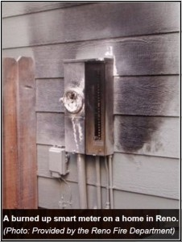After recently reporting on smart meter-related fires in Canada, Pennsylvania, Oregon, and Florida, the latest reports are coming out of Nevada.
As reported by the Reno-Gazette-Journal on September 13th:
“The Reno and Sparks fire chiefs are asking the Public Utilities Commission to investigate the safety of smart meters installed by NV Energy on homes throughout the state in the wake of a troubling spate of blazes they believe are associated with the meters, including one recent fire that killed a 61-year-old woman.”
The utility company (NV Energy) maintains that the death of the woman in late July is not related to a smart meter, yet a forensic expert hired by the City of Reno wrote that the smart meter cannot be ruled out as the source of blaze and states that:
“Data tends to suggest the meter may have failed.”
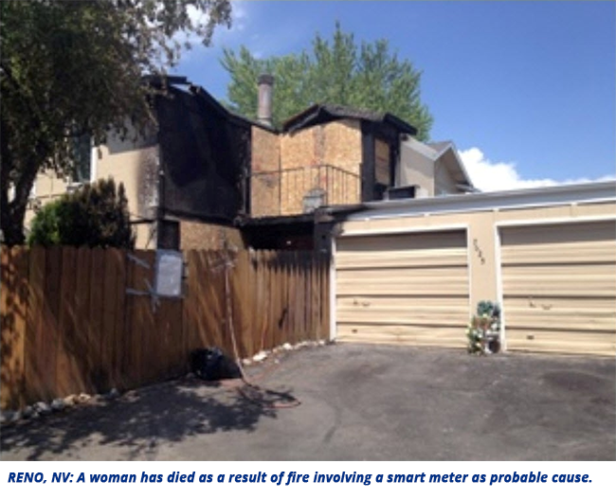
Although the definitive cause of the Reno, Nevada fire-related death remains in dispute, the Fire Chiefs from both Reno and Sparks, Nevada said they have become increasingly concerned by the number of blazes that appear related to the smart meters.
Of the nine fires in Reno and Sparks that appear to be linked to the smart meters, seven resulted in minor property damage. But one of the fires in Reno burned a man’s face. The meter burst into flames when he flipped a breaker switch, scorching him. He put out the flames with a fire extinguisher and was treated at a local hospital.
The forensic investigator that examined the Rhinestone Circle smart meter (where a fire resulted in a death) also examined three more smart meters associated with fires in Reno and Sparks. He found evidence that each of the three meters—one from Reno on Arletta Drive and two from Sparks—failed. “It is probable the Arletta meter did fail, resulting in the ignition of the fire,” wrote the investigator.
Fire officials say that smart meter fires are particularly concerning because they start on the outside of the house, won’t be picked up by indoor smoke detectors, and can escape immediate notice. “The occupants inside may not even be aware the house is on fire. This is very alarming to me,” said Sparks Fire Chief Tom Garrison.
NV Energy utility representatives generally won’t even use the term “fire.” They state that the company has responded to 70 “consumed meters,” describing a consumed smart meter as one that has had its plastic casing “melted or breached and there can be soot.”
Fire Chief Garrison said it’s difficult to tell homeowners how to react at this point:
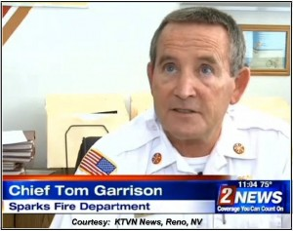“I would say be very aware, very vigilant about any type of potential electrical problem they might see in their home,” he said. “If you noticed any burned electrical panel, any smoke, even if it’s small, wispy smoke, if the meter is extremely hot, or you hear a noise or see any arcing, call 911 and the fire department will come out and ensure the meter is properly checked.”
We have a suggested simple and safe solution to the problem. Get rid of all so-named smart meters. Let’s do it for the sake of life, and property – as well as peace of mind.

Update from the Nevada State Fire Marshal: “Smart Meters Warrant Investigation”
In an updated article from the Reno-Gazette-Journal on September 16th:
“Almost two years after he issued a report finding ‘no systemic fire problem’ associated with NV Energy’s installation of smart meters on homes across the state, Nevada Fire Marshal Peter Mulvihill said new information has come to light that warrants further investigation into whether the meters are safe.
Mulvihill acknowledged that the data he relied on to determine that NV Energy’s smart meters did not pose a fire threat was incomplete, but said his findings were valid at the time.
This year, Mulvihill said his office has received two reports each from Reno and Sparks in which investigators ‘conclusively found the meter to be the origin.’”
—————————————
Source Material for this Article:
“Reno, Sparks Fire Chiefs Call for Smart Meter Probe,” at:
http://www.rgj.com/story/news/2014/09/13/reno-sparks-fire-chiefs-call-smart-meter-probe/15580069/
“Rhinestone Circle Fire Victim Dies in Hospital,” at:
http://www.mynews4.com/news/local/story/Rhinestone-Circle-fire-victim-dies-in-hospital/dHlyzshLm0Wr-sjs_OxsQQ.cspx
“Nevada Fire Marshal: Smart Meters Warrant Investigation,” at
http://www.rgj.com/story/news/2014/09/15/state-fire-marshal-smart-meters-warrant-investigation/15698635/
About the Author
K. T. Weaver is a health physicist who was employed in the nuclear division of a leading electric utility for over 25 years. He served in various positions, including Station Health Physicist, Senior Health Physicist, corporate Health Physics Supervisor, and corporate Senior Technical Expert for Radiobiological Effects. K.T. has earned a B.S. in Engineering Physics and an M.S. in Nuclear Engineering with a specialty in radiation protection. He also operates the “SkyVision Solutions” website at www.skyvisionsolutions.org.

About the Author
K.T. Weaver is a health physicist who was employed in the nuclear division of a leading electric utility for over 25 years. He served in various positions, including Station Health Physicist, Senior Health Physicist, corporate Health Physics Supervisor, and corporate Senior Technical Expert for Radiobiological Effects. K.T. has earned a B.S. in Engineering Physics and an M.S. in Nuclear Engineering with a specialty in radiation protection. He also operates the “SkyVision Solutions” website at www.skyvisionsolutions.org. K.T's articles are copyrighted ©SkyVision Solutions and Smart Grid Awareness.
------

https://takebackyourpower.net/couple-escapes-house-fire-dogs-killed-smart-meter-blamed/

Couple escapes house fire, dogs killed: smart meter blamed
October 14, 2014
by K. T. Weaver
cover-up, damage, Detroit, DTE Energy, fires, safety, smart meters
2 Comments
FacebookTwitterSubscribe

by K.T. Weaver, for Take Back Your Power

Investigators now admit the smart meter “may have played a role in the fire.”
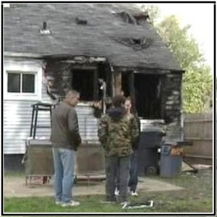A couple barely escaped a house fire with their lives in Detroit, Michigan, early Sunday morning, October 5th, 2014. Sadly, their two dogs were killed in the blaze.
The homeowner blames the recently installed “smart” meter for the fire.
“It was DTE… why my dogs are dead, why my family is ruined, why I have no house, why I have nothing.”
Investigators from Detroit’s Fire Department say two circuit boxes were connected to the “smart” meter outside the house and one of them blew, but it wasn’t immediately clear to investigators whether the smart meter was the cause of the fire.
However, investigators confirmed on October 7th that the “smart” meter “may have played a role in the fire.”
http://www.myfoxdetroit.com/clip/10658985/family-believes-smart-meter-started-fire
(please be patient while video loads)
For any specific fire, it can be difficult to determine if the cause of the fire is the “smart” meter even if the meter is located at or near the origin of the fire. What is disconcerting, however, is how quickly the utility company will dismiss a “smart” meter as the cause of a fire even when fire department investigators will simply state that the cause is “undetermined.”
In this case, it appears that the “smart” meter on the burned home in Detroit was manufactured by Itron.
There is no word yet about forthcoming legal action against DTE by the homeowner.

Updated information: October 7, 2014
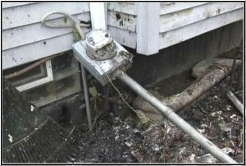As initially reported by a local Detroit TV station, a house fire occurred where the homeowner blamed a “smart” meter for the death of his two dogs and the loss of his home. Fire investigators confirmed on October 7th that the “smart” meter “may have played a role in the fire”.
However, investigators also found evidence of a legal marijuana growing operation in the basement of the home. Additional circuits may have been added for this grow operation which were not properly installed by an electrician. This possible evidence needs to be considered as part of the full fire investigation, but it is hoped it does not unduly allow the utility to deflect responsibility for this failure and the resulting harm — like so many other utilities have.
Source material for this article:
Couple escapes fire, blames smart meter, WJBK-TV | Fox 2 News at:
http://www.myfoxdetroit.com/story/26710141/couple-escapes-fire-blames-smart-meter
House fire that killed two dogs may have started from legal marijuana grow operation, WJBK-TV:
http://www.myfoxdetroit.com/story/26730067/house-fire-that-killed-two-dogs-may-have-started-from-marijuana-grow-operation
SEE ALSO:
• Fatal fire in Nevada, smart meter suspected: “Be very aware, very vigilant” says Fire Chief (Sept 2014)
• Man dies in “smart” meter fire (July 2013)
• Saskatchewan, Canada: SaskPower to replace 105,000 faulty “smart” meters (July 2014)
• Portland, OR: PGE to replace 70,000 faulty “smart” meters (July 2014)
• Lakeland, FL: Lakeland Electric to replace over 10,000 faulty “smart” meters (August 2014)
• Arizona: Are tens of thousands of defective “smart” meters being stealthily replaced in Arizona? (Sept 2014)
• Philadelphia, PA: PECO replaces 186,000 faulty “smart” meters (October 2012)
• News & articles on fires – Take Back Your Power
• Archive of hundreds of documented “smart” meter fires – EMF Safety Network
-----------

https://takebackyourpower.net/saskpower-ceo-resigns-following-investigation-into-smart-meter-catastrophe/

SaskPower CEO resigns following investigation into smart meter “catastrophe”
October 31, 2014
by K. T. Weaver
catastrophe, CEO, fires, government, safety, Saskatchewan, SaskPower, smart meters
7 Comments
347
SHARES
FacebookTwitterSubscribe

by K.T. Weaver, for Take Back Your Power
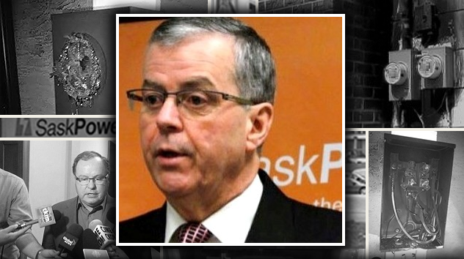
SaskPower CEO Robert Watson has resigned — without severance — after an investigation into “smart” meter fires throughout Saskatchewan.
As reported in late July, following a series of fires throughout Saskatchewan, Canada, “SaskPower ordered to remove all 105,000 smart meters in the province.”
On October 27th, the Government of Saskatchewan released the results of a scathing review on the smart meter “debacle” which is now commonly being referred to as a “catastrophe.” The report concluded that “customer safety was not given enough priority.”
SaskPower CEO Robert Watson resigned his position immediately following the release of the report on the smart meter program.

Findings from the investigation
According to the government’s review:
“The primary issue of catastrophic meter failures which prompted the AMI program to be halted was not identified as an initial program risk. When additional information about smart meter fires from other sources came to light, the risk of catastrophic meter failures did not prompt an independent reevaluation of the risk related to Sensus smart meters.”
Additional key findings:
- Moisture and contaminants getting inside the meters were a major factor in the meter fires.
- There is no evidence to indicate the fires were the result of improper installation or hot sockets.
- SaskPower did not adequately consider the potential for significant meter failures resulting in damage to homes.
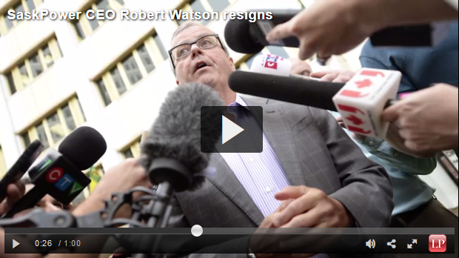
VIDEO: SaskPower CEO Robert Watson resigns amidst smart meter “catastrophe”
Jack Ritenburg, an electrical engineer and head of Ritenburg & Associates concluded that moisture and contaminants inside the meters was the cause of the smart meter fires. He also concluded that “water intrusion due to holes in meter boxes, ‘hot socket’ conditions in the meter box and over voltage in the distribution system” or other “external factors” were not the cause of the fires as previously claimed by the manufacturer:
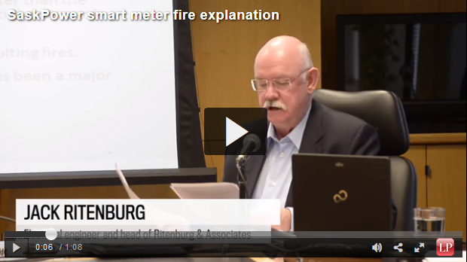
Jack Ritenburg, an electrical engineer and head of Ritengurb and Associates, reports on the suspected causes behind the SaskPower smart meter fires.
According to the independent fire investigation report:
“There was significant precipitation in the previous thirty days for all of the fires. There was significant precipitation in five of the fires within the preceding two days. The remaining three fires had light precipitation within the preceding two days. There is evidence that moisture and contaminants have been getting into the meters and possibly being trapped.”
“Hot socket issues have been flagged as a possible reason for some of the meter failures. … [W]e feel that a hot socket condition resulting in a destructive meter failure and fire are not likely.”
“Sensus has claimed that some of the smart meter fires were caused by utility over-voltage. … We have not found any evidence to support that a significant over-voltage occurred and resulted in a destructive meter failure.”
The photo below shows electrical arcing inside a smart meter that was taken out of service under the category “Display Error.” This failure is in the same location as smart meters which suffered a catastrophic failure.
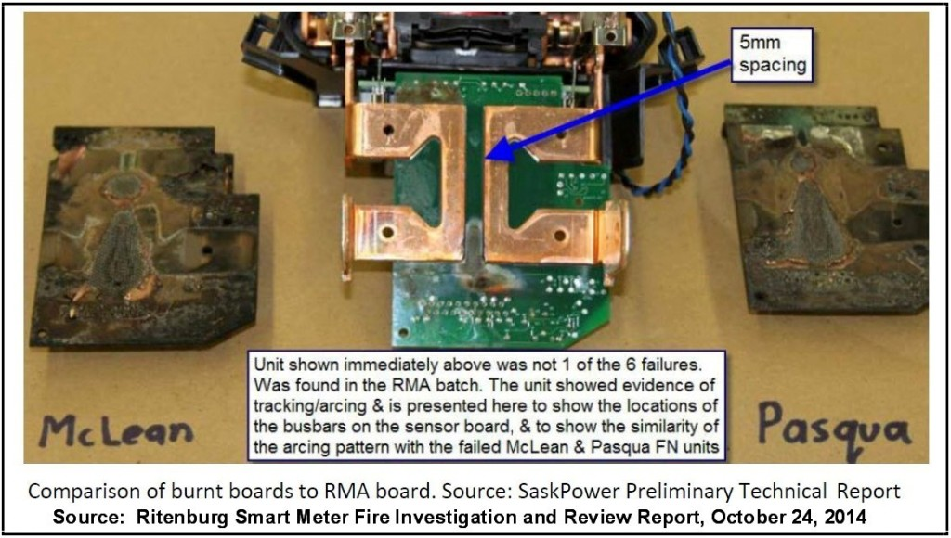
The following photo (below) shows a meter that was taken out of service by SaskPower that has staining from smoke and evidence of moisture at the bottom of the meter. This meter had not yet suffered a catastrophic failure.
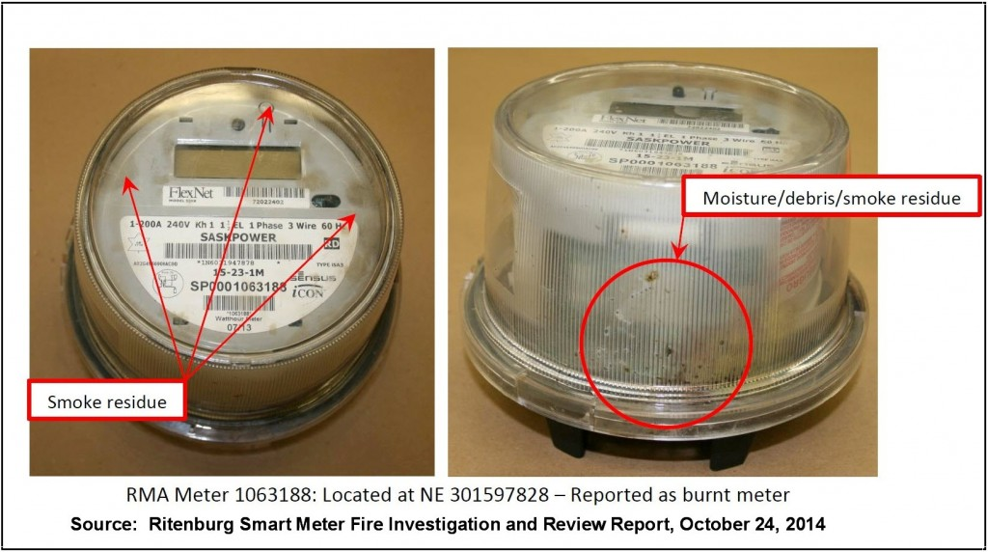
The fire investigation report concluded with the following statements:
“In view of the above, we are of the opinion that moisture and contaminants within the meter has been a major factor in the meter failures and ensuing fires.”
“As there is some danger with destructive meter failures and potential resulting fires, we recommend that the existing Sensus Generation 3.3 meters be replaced as soon as possible. As the existing meter fires have had a close relationship to precipitation levels, SaskPower might wish to consider replacement no later than the end of winter and before the spring thaw and spring rains begin.”
Just to be clear, the fire investigation report reveals that the principal problem is primarily rain water (and/or condensation along with other contaminants) that gets into the smart meters themselves, causing arcing across electronic components with eventual catastrophic failure of the meter with a possible explosion or fire. Furthermore, based upon a review of the investigative report, it is clear we basically have “cheap” meters with a number of design deficiencies which includes uninsulated busbars in close proximity to printed circuit boards and which further allow easy entry of water and dust into the meter enclosures.
Bottom line, … the existing smart meters on people’s homes still present a fire risk in Saskatchewan and elsewhere. In addition, these types of problems would not occur with traditional analog meters that do not contain fragile electronic components.

Smart meters a catastrophe
As a supplement, this website will quote a portion of an October 28, 2014, article in the Leader-Post entitled SaskPower smart meters a ‘catastrophe’:
“Lest there still be any doubt how badly bungled the SaskPower smart meter debacle was, consider how frequently lawyers, technical specialists and others used the word ‘catastrophic’ in their joint review released Monday.
‘The primary issue of catastrophic meter failures which prompted the AMI (Advanced Meter Infrastructure) program to be halted was not identified as an initial program risk,’ stated the $500,000 Crown Investments Corp. (CIC) report entitled Smart Meter Review.
‘When additional information about smart meter fires from other sources came to light, the risk of catastrophic meter failures did not prompt an independent re-evaluation of the risk related to Sensus smart meters.
An escalation of the risk assessment could have prompted additional investigation, testing and either closer monitoring of installed meters or a pause to the rollout of smart meters until issues were better understood.’
‘Catastrophic’ in Monday’s report refers to not just the eight fires started by the smart meters, but occasions when things like smoking in the smart meters – largely due to moisture or debris getting inside what should have been a sealed casing – might have easily led to fires. In all, there were some 359 incidents of meter failure, although the majority were for things like improper readings.
Yet according to the review – [comprised] of three separate reports by Ritenburg and Associates looking into technical issues, Robertson Stromberg commissioned to look at legal matters, and PwC asked to review procurement and contract management – little or no thought was ever given to the inherent risk of catastrophic events.”
SEE ALSO:
• Vacaville, CA: Man dies in “smart” meter fire – StopSmartMeters.org (July 2013)
• Saskatchewan, Canada: SaskPower to replace 105,000 faulty “smart” meters (July 2014)
• Reno, NV: Fatal fire, smart meter suspected: “Be very aware, very vigilant” says Fire Chief (Sept 2014)
• Portland, OR: PGE to replace 70,000 faulty “smart” meters (July 2014)
• Lakeland, FL: Lakeland Electric to replace over 10,000 faulty “smart” meters (August 2014)
• Arizona: Are tens of thousands of defective “smart” meters being stealthily replaced in Arizona? (Sept 2014)
• Detroit, MI: Couple escapes house fire, dogs killed: smart meter blamed
• Philadelphia, PA: PECO replaces 186,000 faulty “smart” meters (October 2012)
• News & articles on fires – Take Back Your Power
• Archive of hundreds of documented “smart” meter fires – EMF Safety Network

